Builder Pattern

The aim of this pattern is to separate the logic of creation of an object from the logic that use that object, this could be needed in many different cases. Some of them are:

- When creating objects with long list of constructor parameters and the object creation must be regulated by a set of restrictions and validations in order to ensure that the object is created in a stable state.
- When the data to create an object comes from a xml parser or any other stream parser, in this case we first need to parse all the data needed for the creation of the object and once we have obtain all of it , we construct the object.
- When there are different options or configuration for and object and we do not want to expose the inners of the different object configuration to the software that instantiate the object.
- When the object has got many attributes, many of them with defaults. And we do not want to create a different object constructor for each combination of default that we want to override.

In the pattern described by Gof (Gang of Four) has got 4 different participants which are:

Product – It is the object or entity that we want to construct.
Builder – It is general definition, it can be an interface with on only method that is build().
Concrete Builder – It is the real implementation of the class that will contain the logic and the knowledge to construct the product.
Director - It contains logic to build complex composite objects using different builders. This participant is not always implemented and often the client code use the builders directly.

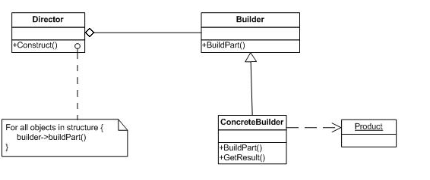

Our implementation

In our case the Product are the different entities we want to instantiate, the builder is our BuilderI<T> interface, the concrete builders are the different builder implementations and the Director is our BuilderDirector that aggregate all the static methods to create builders in the system.

And additional, but not less important, motivations to implement a builder pattern in domain model base application are to facilitate testing. If the creation of unit tests is not an easy task then they will not be created.
This pattern facilitates the creation of tests since the creation of our initial dataset can be done in few lines thus avoiding the use a database or a mock database.

For example, in order to create a person in a specific company with a specific manager using normal constructors the code is like follows:

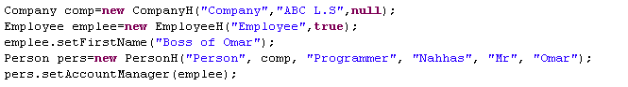

Using Builders the code is like follows

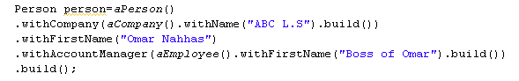

It is clear that the code is much more simple and easy to understand and write, another maybe not so clear advantage is that using builder we do not need to provide all the attributes that the constructor of the entity demands. A third advantage is that every builder contains a set of defaults for each entity so we only modify the ones that we need for our unite test, trusting that all other attributes are not null and has got sensible defaults. This is especially important when building objects that are part of a hierarchy. For example, person extends contactactable likewise Employee and Company, using the first snipped we are not populating any of the attributes of contactable when creating any of the objects but using the second snipped actually will populate all the attributes of contactable with all the defaults values present inside the contactable builders. Another advantage is that we can implement a validation of the object state in the build process (build method) where more complex validations can be achieved like constrains based one two or more parameters.

A peculiarity of this implementation is that is all the “set” methods in the builder (actually “with” methods) return the same instance of the builder so you can concatenate the methods one after the other producing more clear code. This simulates named optional parameters as found in Ada and Python.

But all this advantages does not come without some challenges, the two main challenges we had to face in implementing the builder pattern were: first implementing inheritance and second solving the problem with circular dependencies.

Implementing inheritance with builders.

Having a inheritance model like follows:

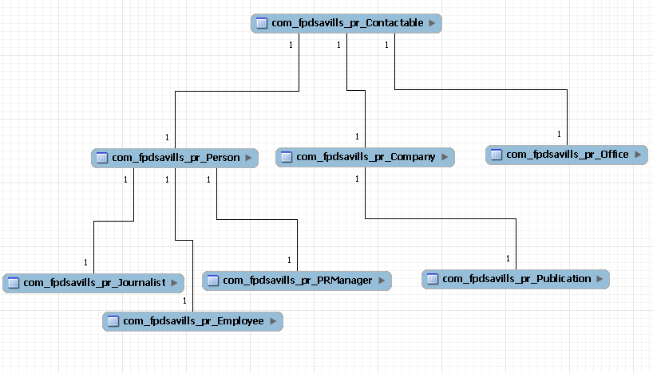

In order to show the difficulties of implement inheritance, let’s take the example of the Employee. Employee extends Person which extends Contactable. ContactableBuilder contains the defaults for the Contactable attributes and the ‘set’ methods (‘with’ methods in this case) of the Contactable attributes too. As we have mention before all the ‘with’ methods return ‘this’ which is the instance of the builder it self. And only the method build will build the object.

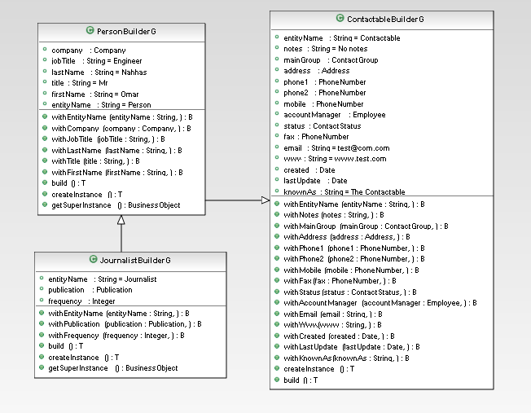

The first challenge is to make the Employee builder to build Employee object but using the defaults present in PersonBuilder and ContactableBuilder without actually copying the code present in PersonBuilder and ContactableBuilder, obviously the only way to do this is using inheritance between the builders it self, so EmployeeBuilder will inherit form PersonBuilder and the former one will inherit from ContactableBuilder. Now the second challenge is to make all the inherited setters of the PersonBuilder and ContactableBuilder returning type of EmployeeBuilder instead of PersonBuilder or ContactableBuilder. To solve both problems we had to use Java Generics in a quite complex generic implementation of builders that can be found in the appendixes.

The second challenge was resolving circular dependencies. Using the same example as before when building a Contactable with ContactableBuilder there is an attribute to initialize which is ‘account Manager’ of type employee which is a subtype of contactable itself. So when calling the method build() in Contactable will try to build an Employee in order to initialize account Manager , and building Employee will build also a contactable because of hierarchy this will create an infinite loop.

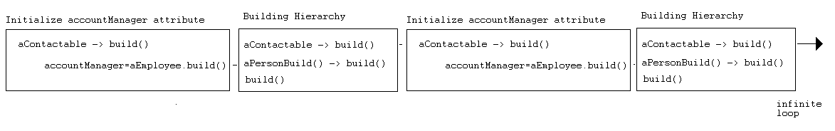
In order to solve this problem and still be able to keep a complete set of defaults when building a Contactable. We needed to use a variation of “lazy loading” which I called “lazy building”. Lazy loading is been used by many ORM, since “dynamic proxy” capabilities were included in JVM 1.3.

Dynamic Proxy
The term proxy comes from the proxy pattern proposed by Gof in winch a class functions as a interface of something else. The classic proxy patters described a class that is used as an interface between the client code and some kind of resource that for any reason is not possible to duplicate. One example could be a class “Connection ()” with the method “getConnection ()” that returns always the same connection no matter with instance of “Connection” you use.

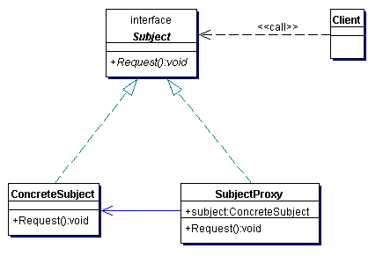

Dynamic Proxy is a feature introduced in java 1.3 that allows implementing the proxy pattern in runtime by allowing the creation of dynamic implementations of one or more interfaces in runtime. Using this, you can intercept all the calls(method calls) made to an instance of a specific interface. Once intercepted the interceptor object can execute specific logic and then it may redirect the call to a real instance of the interface it is representing.

This technique can be use to implement a database and transaction management , access control , creating dynamic mock object for unit testing , class decoration and any other Aspect oriented-like task included “Lazy Loading”.

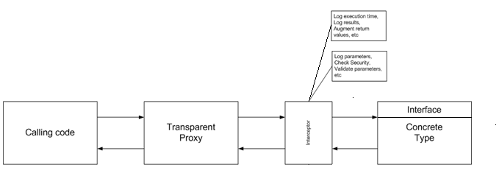
Lazy Loading and Lazy Building
Lazy Loading uses this same pattern to instantiate transparent proxies in the place of real entities and then, the first time a method is called on that entity the transparent proxy will load the instance of that entity and redirect the call to it, subsequent calls will be redirected without the need of loading the entity instance again.

Back to the problem we faced of “circular dependencies”. We decided to apply this concept of “lazy Loading” and implement “lazy building” for all the entity attributes that are of type Business Object (any entity of our domain model). So using the same example as before , now when building a Contactable the application will not try to build a fully fledge instance of Employee, but it will instantiate a lazy proxy that will build the Employee instance the first time we try to access it. All the details can be found in the annexes.

